1. Sign In to your aws acc
2. Select all services
3. Select EC2  
   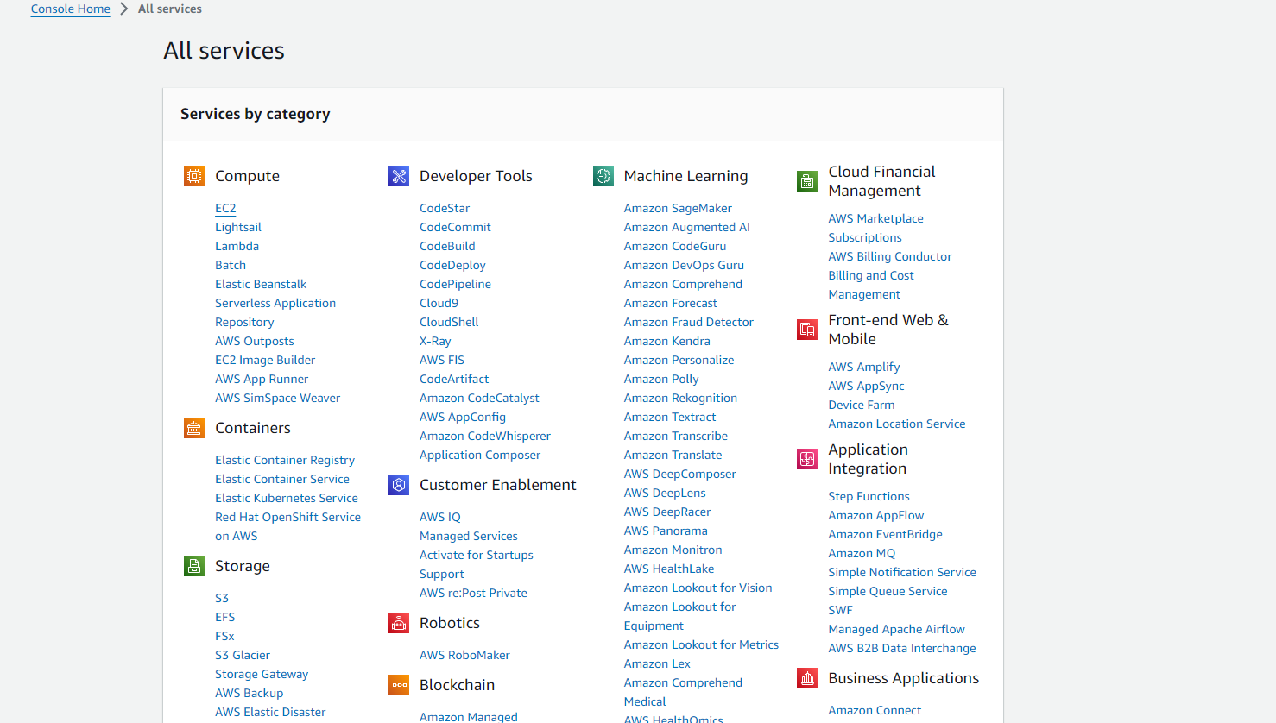
4. Launch Instance
5. Put name , create key value pair pem and save
6. Select Windows
7. Launch the instance
8. Go to instances and refresh  
   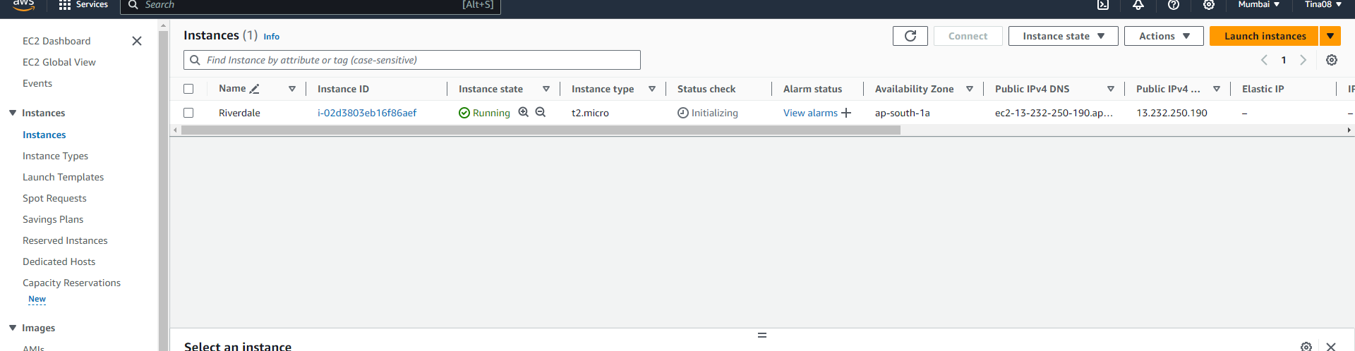
9. It will initialize and then start running
10. Select the instance   
    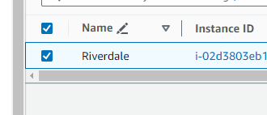
11. Click on connect, for connecting to RDP client
12. Click on get password and save the pass
13. Upload key value file  
    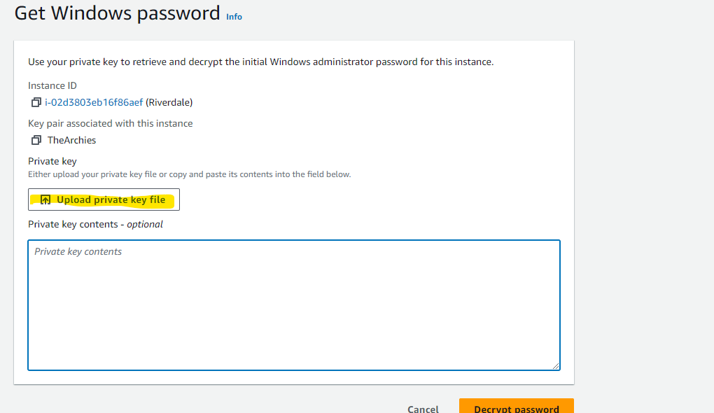
14. Decrypt pass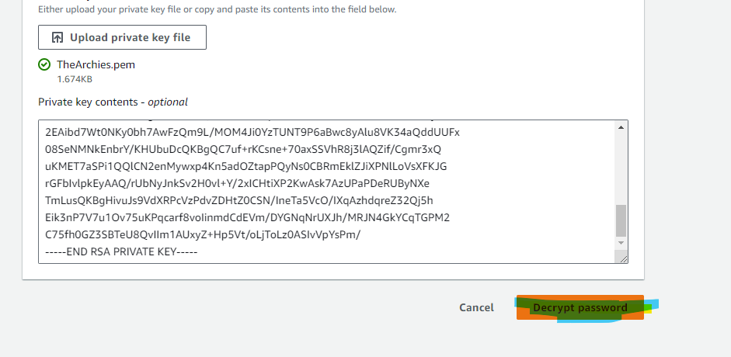
15. Save the pass- iM)7nJ34\*VZ1-\*BuqbsspMjYby;Z;C7G  
    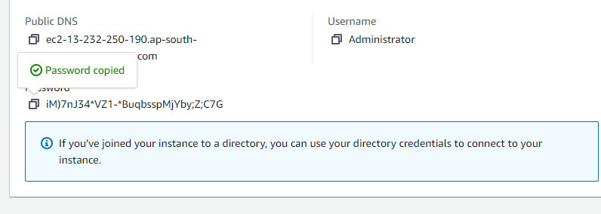
16. Go back to Instance , connect then download RDP file
17. Open RDP   
    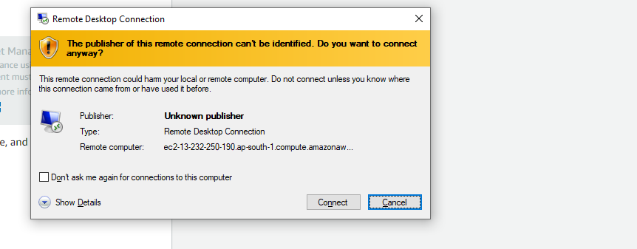
18. Connect RDP :  
    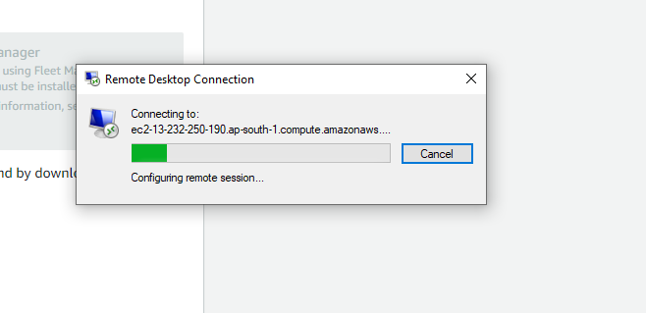
19. Enter creds  
    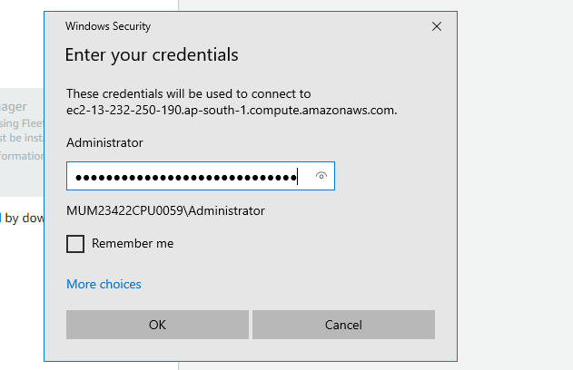
20. 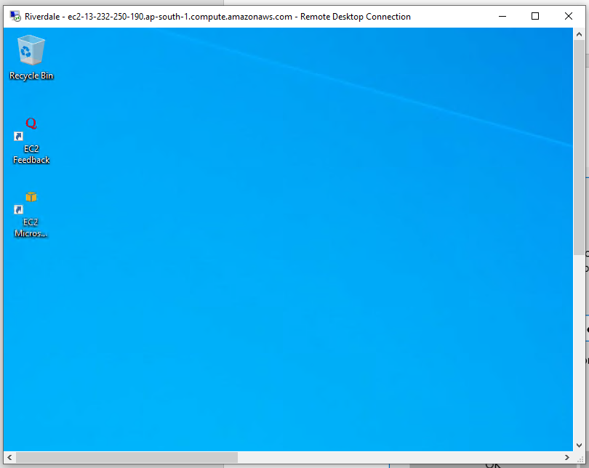
21. Close RDP
22. Go back to instances
23. Terminate the instance  
    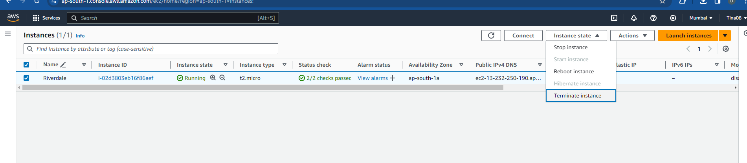  
    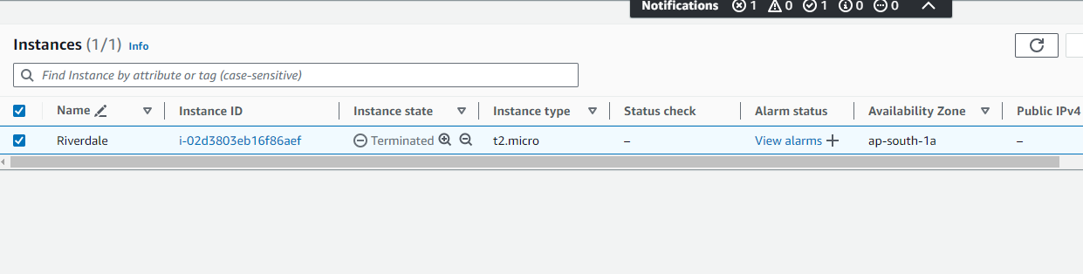
24. Launch a new instance for Linux:
25. Write a new web server name and Select Ubuntu server  
    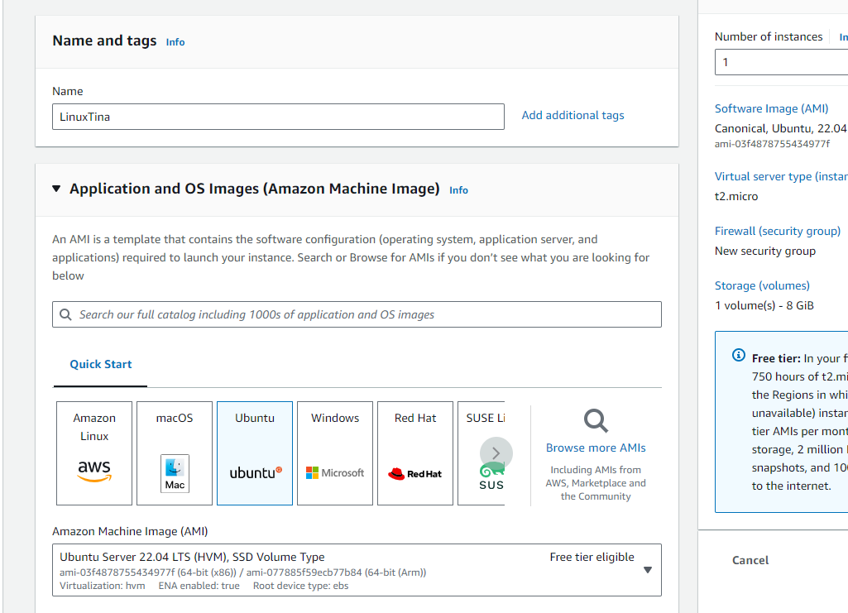
26. Create a new key value pair and select ppk  
    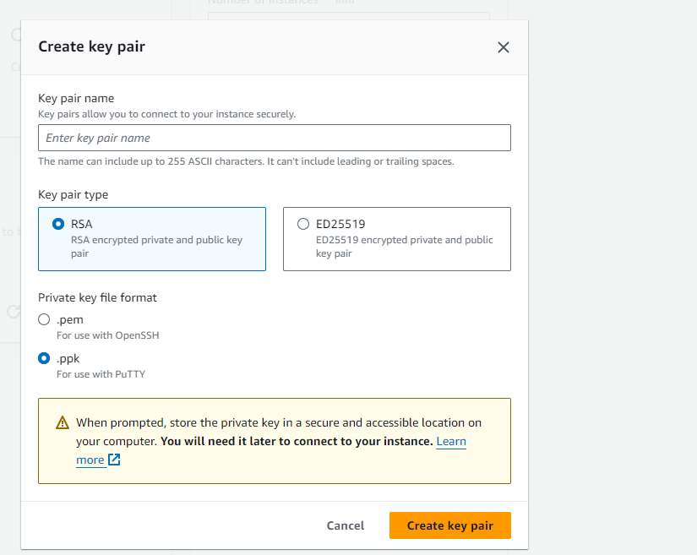
27. Download putty.exe from google
28. Select and downlad exe file  
    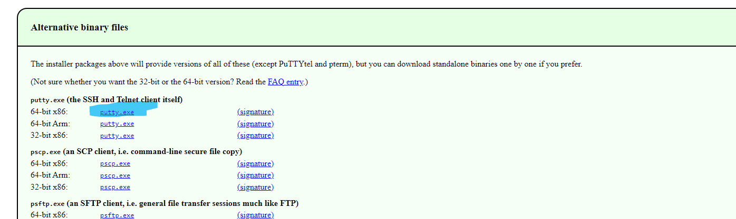
29. Create ppk key value pair and save the file
30. Allow all traffic  
    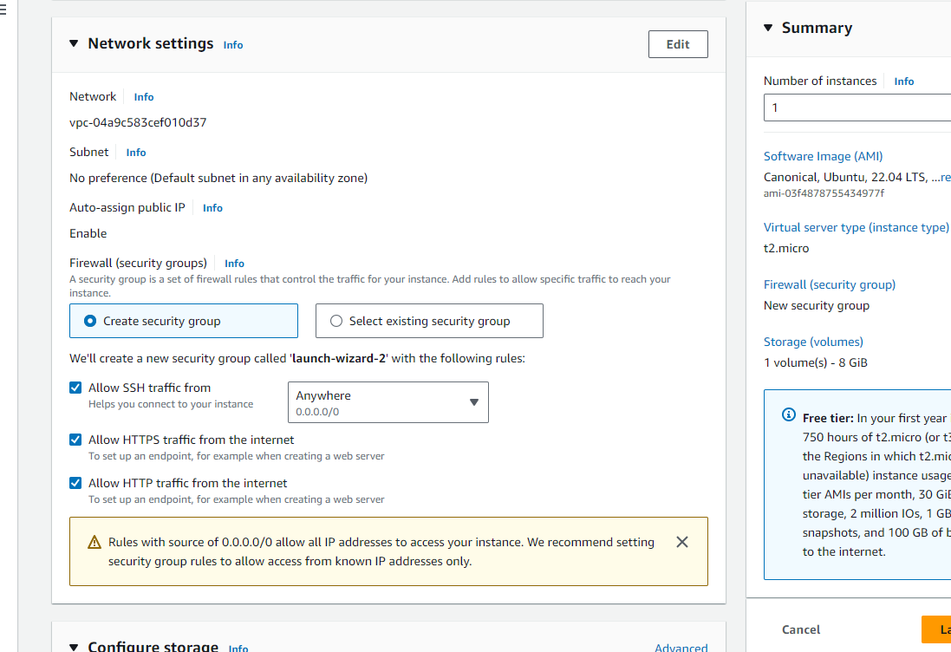
31. Launch Instance
32. Go to Instances and refresh
33. Select and copy Public IPV4 address  
    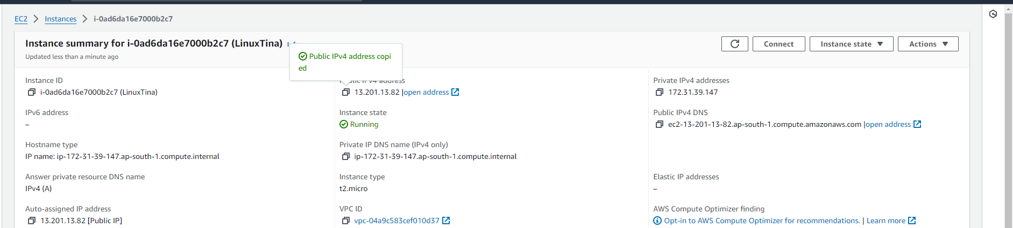
34. Go to putty, paste IP address  
    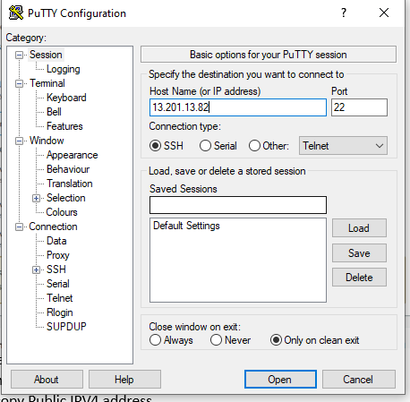
35. Category -> SSH -> Auth -> Credentials -> Browse and select ppk file  
    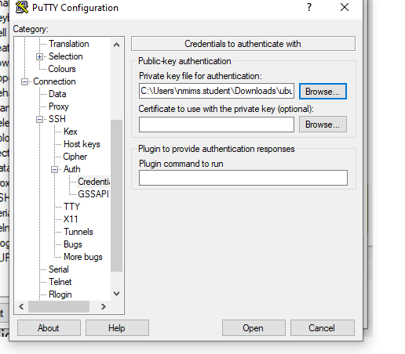
36. Putty will launch
37. Login as Ubuntu  
    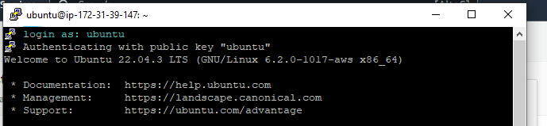
38. Type commands  
    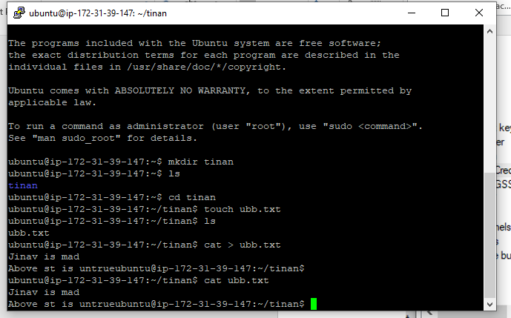  
    control + D
39. Terminate the instance , close putty